Small Rhombidodecacron

Introduction
# Source: AI Source: Provided by: [Data Path: Persons Table -> ID Column: 1, Name_En Column: Motasem Essam] -> From: [ChatGPT] on [7/25/2026]
The Small Rhombidodecacron is a non-convex polyhedron in geometry. It is also known as the Small Dipteral Ditriacontahedron.
It is the dual of the Small Rhombidodecahedron. It has 60 intersecting, bow-tie-shaped faces called antiparallelograms.
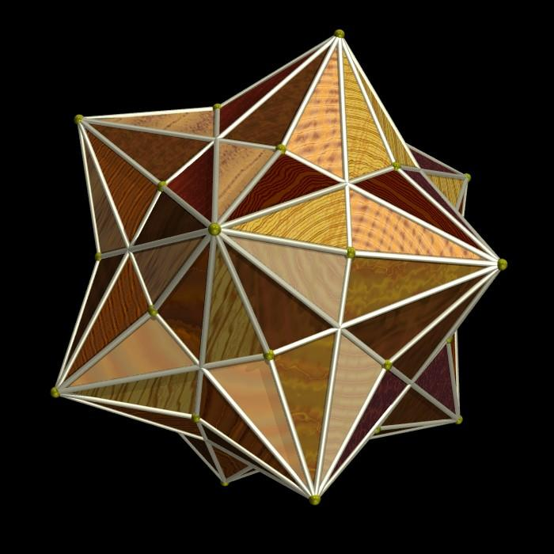

Main Properties
# Source: AI Source: Provided by: [Data Path: Persons Table -> ID Column: 1, Name_En Column: Motasem Essam] -> From: [ChatGPT] on [7/25/2026]
- Type: Non-convex isohedral polyhedron
- Faces: 60
- Edges: 120
- Vertices: 42
- Symmetry: Icosahedral symmetry ($I_{h}$)
- Dual solid: Small Rhombidodecahedron
- Dihedral angle: Approximately ${154.12}^{°}$.

Faces
# Source: AI Source: Provided by: [Data Path: Persons Table -> ID Column: 1, Name_En Column: Motasem Essam] -> From: [ChatGPT] on [7/25/2026]
The solid has 60 identical antiparallelogram faces.
An antiparallelogram is a crossed quadrilateral that resembles a bow tie. Each face has:
- Two short edges.
- Two long edges.
- Two smaller angles of approximately ${25.24}^{°}$.
- Two larger angles of approximately ${93.03}^{°}$.

Vertices and Edges
# Source: AI Source: Provided by: [Data Path: Persons Table -> ID Column: 1, Name_En Column: Motasem Essam] -> From: [ChatGPT] on [7/25/2026]
The Small Rhombidodecacron contains:
- 42 vertices.
- 120 edges.
- 60 short edges.
- 60 long edges.
The ratio between the long and short edges is the golden ratio:
$$φ=\frac{1+\sqrt{5}}{2}≈1.618$$

Dual Polyhedron
# Source: AI Source: Provided by: [Data Path: Persons Table -> ID Column: 1, Name_En Column: Motasem Essam] -> From: [ChatGPT] on [7/25/2026]
Its dual is the Small Rhombidodecahedron.
The dual relationship means:
- Each face corresponds to a vertex.
- Each vertex corresponds to a face.
- Each edge corresponds to an edge.
The Small Rhombidodecahedron has 42 faces, 120 edges, and 60 vertices.

Euler's Formula
# Source: AI Source: Provided by: [Data Path: Persons Table -> ID Column: 1, Name_En Column: Motasem Essam] -> From: [ChatGPT] on [7/25/2026]
Euler's formula is:
$$V-E+F=2$$
For this polyhedron:
$$V=42, E=120, F=60$$
$$42-120+60=-18$$
The result is $-18$, reflecting its non-convex, self-intersecting structure.

Construction
# Source: AI Source: Provided by: [Data Path: Persons Table -> ID Column: 1, Name_En Column: Motasem Essam] -> From: [ChatGPT] on [7/25/2026]
- Start with a Small Rhombidodecahedron.
- Identify its faces, edges, and vertices.
- Place a corresponding point for each face.
- Connect the points according to the dual structure.
- Form the 60 antiparallelogram faces.

Classification
# Source: AI Source: Provided by: [Data Path: Persons Table -> ID Column: 1, Name_En Column: Motasem Essam] -> From: [ChatGPT] on [7/25/2026]
Polyhedra
<icon name="arrow-down" color="secondary"/>
Non-convex polyhedra
<icon name="arrow-down" color="secondary"/>
Dual polyhedra
<icon name="arrow-down" color="secondary"/>
Small Rhombidodecacron

Important Points
# Source: AI Source: Provided by: [Data Path: Persons Table -> ID Column: 1, Name_En Column: Motasem Essam] -> From: [ChatGPT] on [7/25/2026]
- It has 60 bow-tie-shaped faces.
- It has 120 edges and 42 vertices.
- It is a non-convex polyhedron.
- It has icosahedral symmetry.
- Its edge lengths follow the golden ratio.
- Its dual is the Small Rhombidodecahedron.

Conclusion
# Source: AI Source: Provided by: [Data Path: Persons Table -> ID Column: 1, Name_En Column: Motasem Essam] -> From: [ChatGPT] on [7/25/2026]
The Small Rhombidodecacron is an interesting geometric solid because of its intersecting antiparallelogram faces and its special symmetry. Its relationship with the Small Rhombidodecahedron makes it an important example of a dual polyhedron in advanced geometry.

